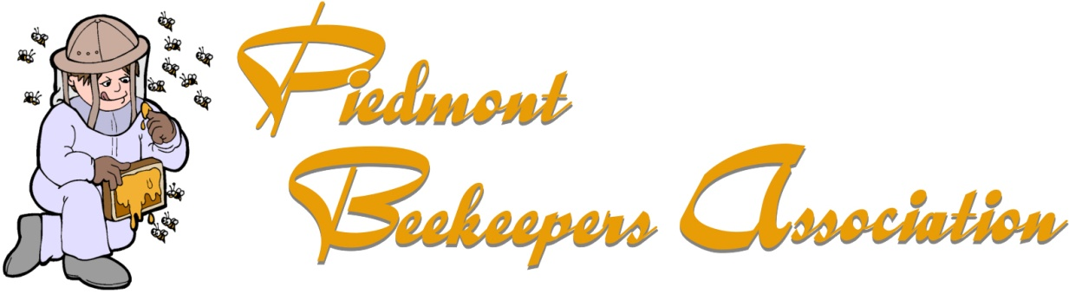
PRESENTS
HONEY BEE DISEASE WORKSHOP
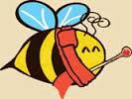
SATURDAY AUGUST 12, 2017
9am – 12pm
RANDOLPH COLLEGE
2500 Rivermont Avenue Lynchburg, Virginia
GUEST SPEAKER - KEITH TIGNOR – VIRGINIA STATE APIARIST
Lecture & Laboratory time followed with on campus hive inspection
TOPICS COVERED (but not limited to):
Varroa mites, Tracheal mites, American Foulbrood, European Foulbrood, Sacbrood, Chalkbrood, Stonebrood, Nosema Ceranae, Deformed wing virus, Small hive beetles, Wax moth, Nosema, Treatments, Nuisance animals, and more
Members $15, Non-members $20
Space will be limited to 24 persons, seats will be reserved by order of payment
Please remit payment to:
Piedmont Beekeepers Association c/o Darryl Garrison
1107 Oakcrest Street Bedford, Virginia 24523
Any questions, please contact Mark Smith: PiedmontBeekeepers@Outlook.com

